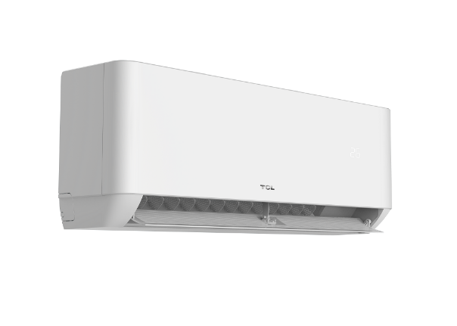

TCL Smart DC Inverter Air Conditioner 18T3 PRO - 1.5 Ton (IoT Wifi Control)

Product details of TCL Smart DC Inverter Air Conditioner 18T3 PRO - 1.5 Ton (IoT Wifi Control)

* DC Inverter
* IoT Wifi Control
* Energy Efficient
* Gold Fin
* Anti Bacterial Filter
* Deep Clean
* Eco Mode
* Gentle Breeze
* Low Noise